**Average Data Scientist salary in America**

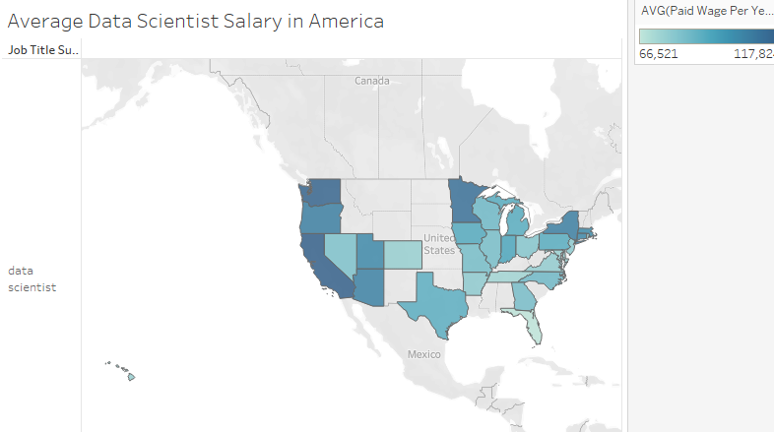

**Average Data Analyst salary in America**

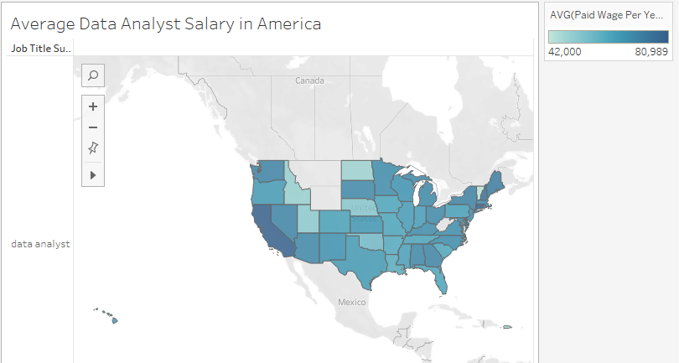

**Average Business Analyst salary in America**

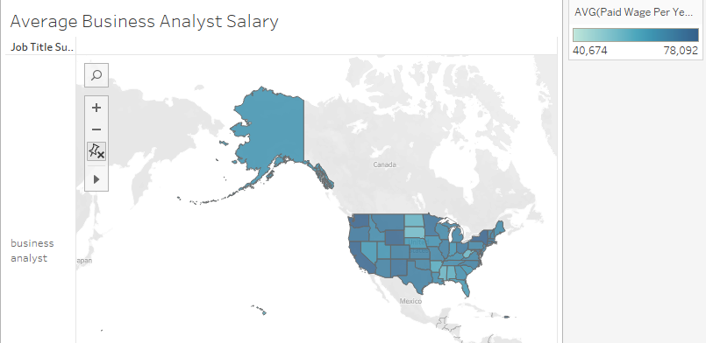

**Out of all US states, I choose California, Washington, Hawaii, Wisconsin and New Mexico as my preferred state.**

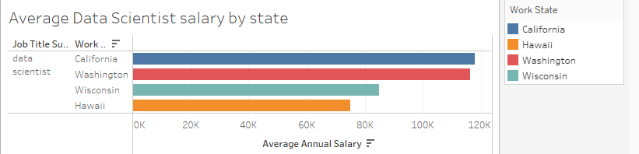

Note: Don’t have data for New Mexico for data scientists.

When we compare the salary of data scientists, California and Washington have the highest average salary. In contrast, Wisconsin and Hawaii have the lowest average salary when we compare them with California and Washington. Because of the six figure data scientist salary, many people want to move to live in California and Washington state. They want to become rich. However, we should not only look at the salary. We also need to determine the cost of living and taxes. According to *businessinsider.com*, the living wage in California is $99,971 and the living wage in Wisconsin is $67,667. According to *gobankingrates.com*, the real value of $100 in Wisconsin is $108.10 and the real value of $100 in California is $83.60. Therefore, the dollar value changes depending on where you live. When we add a cost of living in our calculation, average data scientists in Wisconsin get paid more than the average data scientists in California.

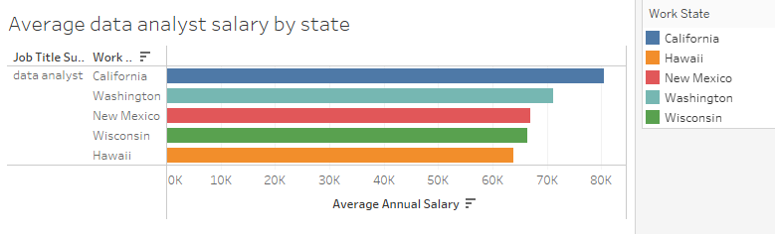

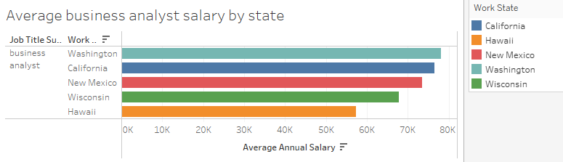

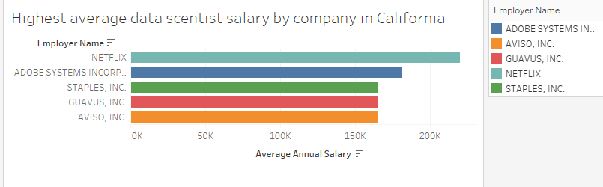

NETFLIX has the highest average data scientist salary in California.

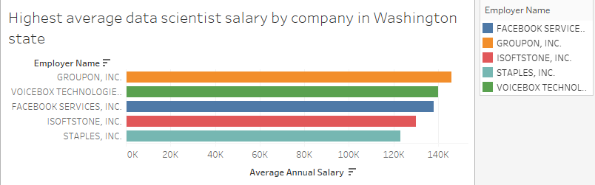

GROUPON, INC has the highest average data scientist salary in Washington state.

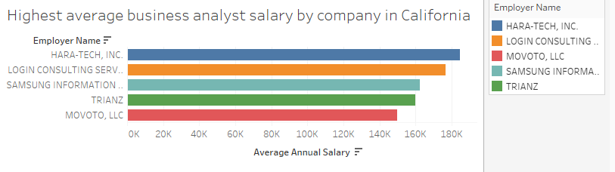

Hara-tech, inc has the highest average business analyst salary in California.

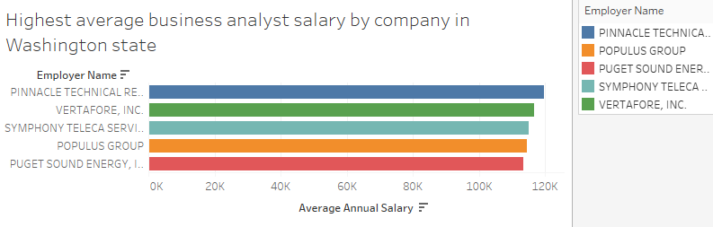

Pinnacle Technical has the highest average business analyst salary in Washington state.